Taris Major
Dr. Mahmoud Eldefrawy
Machine Learning
24 November 2025
Fashion Mnist Results and Final Project Proposal

I ran the same FCNN models using the Fashion_Mnist dataset and got surprising results. The best performing model using the Fashion_Mnist dataset is Adam, then AdamW, then RMSProp and finally Nadam. Adam got an accuracy of 87.94%. These were the graphs generated:
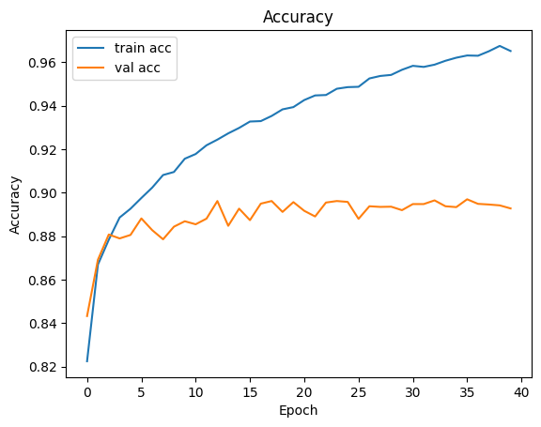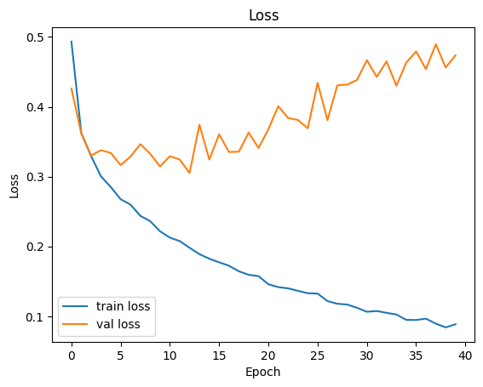
AdamW got an accuracy score of 86.51%. These were the graphs generated:
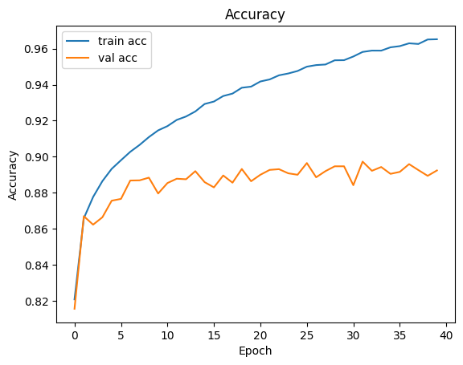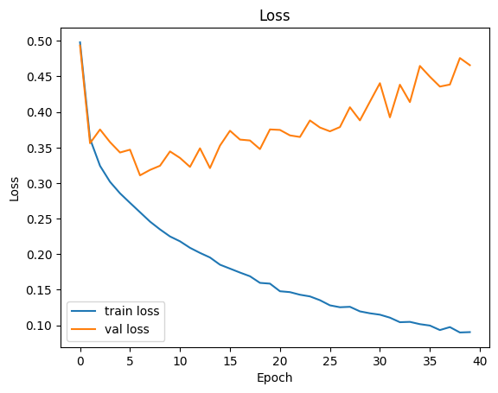
RMSProp got an accuracy score of 85.61%. These were the graphs generated:
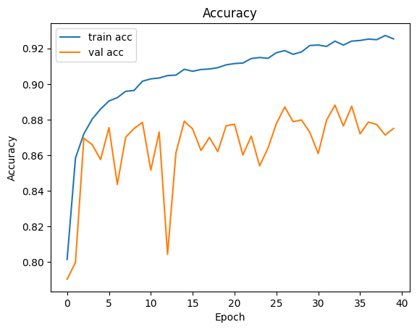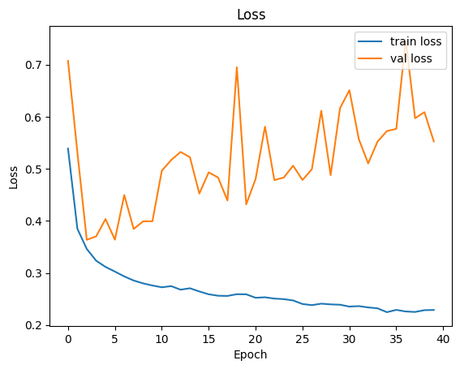
Nadam got an accuracy score of 83.17%. These were the graphs generated:
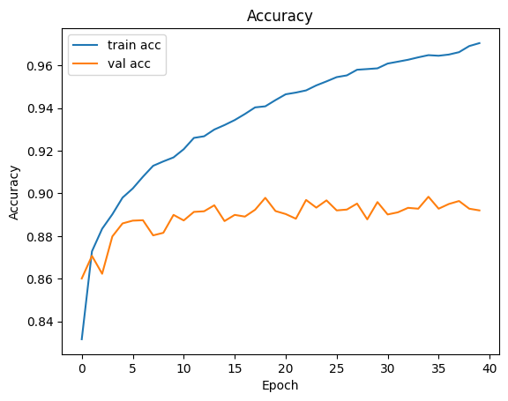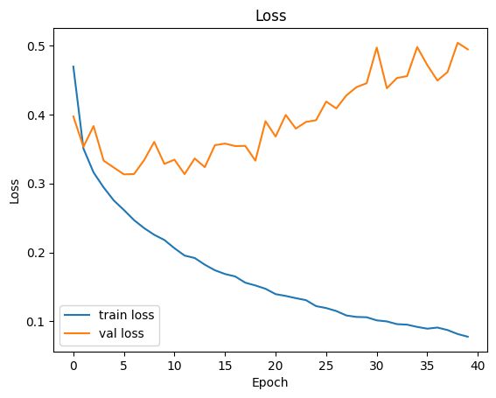
Unfortunately, I was unable to run the models through the CNNs with the time remaining.
Final Project Proposal
For my final project, I am using collected weather data from the Wichita Falls Shepherds Airforce Base to predict the high temperature in the near future. So far, I have made Regression models using Linear and Logistic Regression and models using Decision Trees. I have copied that folder here of all the progress made so far. I will use my knowledge of neural networks to construct a network that relies on a time series next, possibly RNN and do more research into others that have done something similar.

